Pietroiu Robert Adrian

Grupa 1058E

Proiect Baze de Date

**Descriere:**

Proiectul consta intr-o baza de date in care sunt stocate informatiile necesare unui sistem de rezervare a biletelor pentru cinema. Astfel, aceasta consta in implementarea urmatoarelor tabele:

* ***Client:*** – tabela in care sunt inregistrati clientii ce isi rezerva biletele pentru vizionarea filmului, continand urmatoarele coloane: ID_client (cheie primara), nume, prenume, email, numar_telefon
* ***Rezervare:*** – tabela in care sunt stocate inregistrarile facute de catre clienti. Aceasta contine: ID_rezervare (cheie primara), data_rezervare, id_film_programat (cheie externa), id_client (cheie externa), id_loc (cheie externa).
* ***Loc:*** – tabela ce face referire la locul in care vor sta clientii aferenti rezervarilor, formata din: id_loc (cheie primara), numar, id_rand (cheie externa).
* ***Rand:*** – tabela ce face referire la modul in care sunt organizate locurile. Contine: id_rand (cheie primara), numar, id_sala (cheie externa).
* ***Sala:*** – tabela in care se stocheaza informatii despre sala in care se difuzeaza filmul : id_sala (cheie primara), nume, capacitate, cinema (cheie externa).
* ***Cinema:*** – tabela ce face referire la cinema-ul la care a fost facuta rezervarea : id_cinema (cheie primara), nume, adresa.
* ***Film:*** – tabela ce contine informatii utile despre filmul ce urmeaza a fi difuzat, precum: id_film (cheie primara), nume, durata_minute, tip, descriere, anul_publicarii.
* ***Film_programat:*** – tabela ce contine o noua serie de informatii cu privire la film: id_film_programat (cheie primara), ora_inceput, ora_incheiere, pret, id_film (cheie externa), id_sala (cheie externa).
* ***Lista_actori:*** tabela ce face referire la lista in care sunt inregistrati actorii ce joaca in filmul respectiv. Aceasta contine: id_lista (cheie primara), id_film (cheie secundara).
* ***Actor:*** tabela in care sunt salvate informatiile fiecarui actor: id_actor (cheie primara), nume, varsta, id_lista (cheie secundara).

**Schema bazei de date:**

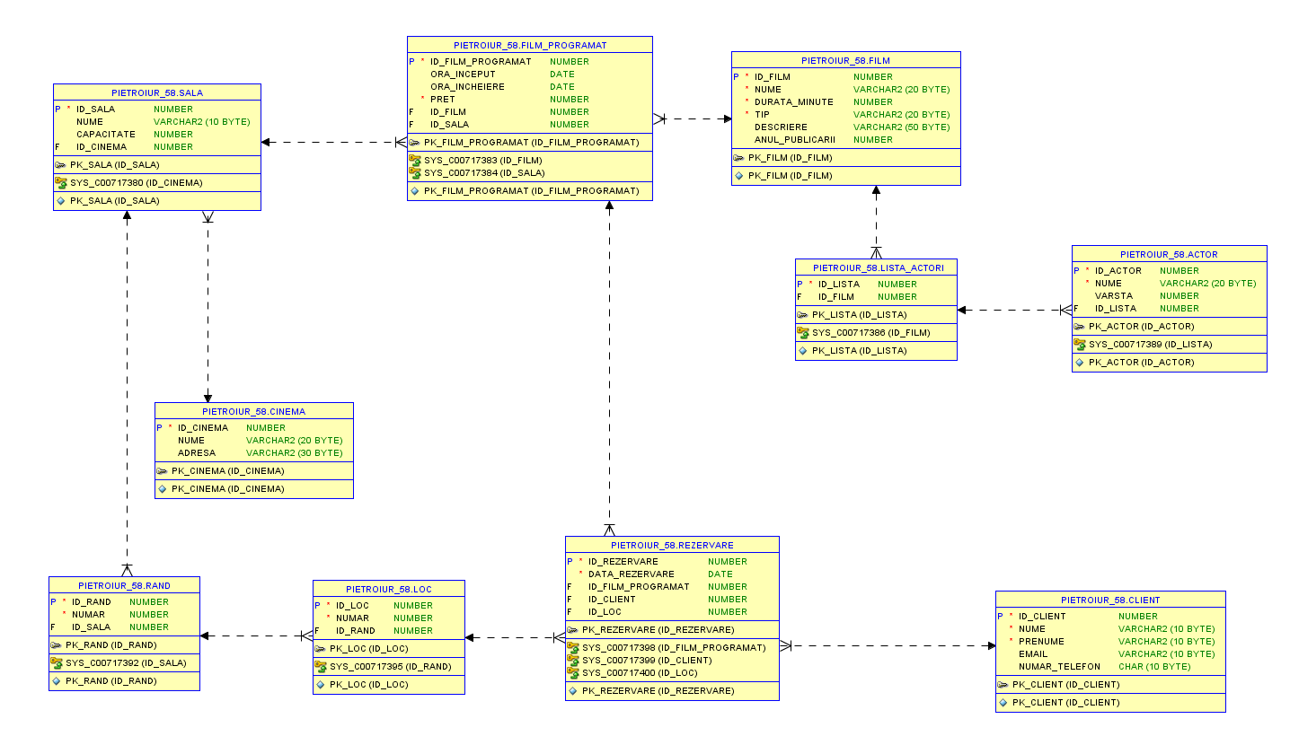

**Codul sursa aferent bazei de date:**

CREATE TABLE CLIENT (

id_client NUMBER CONSTRAINT pk_client PRIMARY KEY,

nume VARCHAR(10) NOT NULL,

prenume VARCHAR(10) NOT NULL,

email VARCHAR(80),

numar_telefon CHAR(10)

);

CREATE TABLE CINEMA (

id_cinema NUMBER CONSTRAINT pk_cinema PRIMARY KEY,

nume VARCHAR(80),

adresa VARCHAR(80)

);

CREATE TABLE FILM (

id_film NUMBER CONSTRAINT pk_film PRIMARY KEY,

nume VARCHAR(80) NOT NULL,

durata_minute NUMBER NOT NULL,

tip VARCHAR(20) NOT NULL,

descriere VARCHAR(50),

anul_publicarii NUMBER

);

CREATE TABLE SALA (

id_sala NUMBER CONSTRAINT pk_sala PRIMARY KEY,

nume VARCHAR(10),

capacitate NUMBER,

id_cinema NUMBER REFERENCES CINEMA(id_cinema)

);

CREATE TABLE FILM_PROGRAMAT (

id_film_programat NUMBER CONSTRAINT pk_film_programat PRIMARY KEY,

ora_inceput VARCHAR(10),

ora_incheiere VARCHAR(10),

pret NUMBER NOT NULL,

id_film NUMBER REFERENCES FILM(id_film),

id_sala NUMBER REFERENCES SALA(id_sala)

);

CREATE TABLE LISTA_ACTORI (

id_lista NUMBER CONSTRAINT pk_lista PRIMARY KEY,

id_film NUMBER REFERENCES FILM(id_film)

);

CREATE TABLE ACTOR (

id_actor NUMBER CONSTRAINT pk_actor PRIMARY KEY,

nume VARCHAR(20) NOT NULL,

varsta NUMBER,

id_lista NUMBER REFERENCES LISTA_ACTORI(id_lista)

);

CREATE TABLE RAND (

id_rand NUMBER CONSTRAINT pk_rand PRIMARY KEY,

numar NUMBER NOT NULL,

id_sala NUMBER REFERENCES SALA(id_sala)

);

CREATE TABLE LOC (

id_loc NUMBER CONSTRAINT pk_loc PRIMARY KEY,

numar NUMBER NOT NULL,

id_rand NUMBER REFERENCES RAND(id_rand)

);

CREATE TABLE REZERVARE (

id_rezervare NUMBER CONSTRAINT pk_rezervare PRIMARY KEY,

data_rezervare DATE NOT NULL,

id_film_programat NUMBER REFERENCES FILM_PROGRAMAT(id_film_programat),

id_client NUMBER REFERENCES CLIENT(id_client),

id_loc NUMBER REFERENCES LOC(id_loc)

);

**Codul aferent inregistrarii datelor in baza de date:**

INSERT INTO CLIENT VALUES (100, 'Pietroiu', 'Robert', 'pietroiurobert65@gmail.com', '0765126290');

INSERT INTO CLIENT VALUES (101, 'Oprea', 'Ovidiu', 'operaovidiu12@gmail.com', '0765124536');

INSERT INTO CLIENT VALUES (102, 'Popa', 'Alexandru', 'popaalexandru54@gmail.com', '0765456899');

INSERT INTO CLIENT VALUES (103, 'Popa', 'Romeo', 'poparomeo88@gmail.com', '0762455671');

INSERT INTO CLIENT VALUES (104, 'Davidoiu', 'Adrian', 'davidoiuadrian24@gmail.com', '0723441577');

INSERT INTO CLIENT VALUES (105, 'Stoica', 'Ionut', 'stoicaionut99@gmail.com', '0798567743');

INSERT INTO CLIENT VALUES (106, 'Florea', 'Marian', 'floareamarian25@gmail.com', '0767562433');

INSERT INTO CLIENT VALUES (107, 'Cristea', 'Bogdan', 'cristeabogdan07@gmail.com', '0787674212');

INSERT INTO CINEMA VALUES (301, 'CINEMA CITY BUZAU', 'Bulevardul Doina Cornea 4, Bucure?ti');

INSERT INTO FILM VALUES(123, 'RUSH HOUR', 120, 'ACTIUNE', '...', 1998);

INSERT INTO LISTA_ACTORI VALUES(55, 123);

INSERT INTO ACTOR VALUES (624, 'Tzi Ma', 60, 55);

INSERT INTO ACTOR VALUES (231, 'Jackie Chan', 68, 55);

INSERT INTO ACTOR VALUES (134, 'Chris Tucker', 51,55);

INSERT INTO SALA VALUES (1, 'S1', 50, 301);

INSERT INTO FILM_PROGRAMAT VALUES(13, '20:00', '22:00', 15, 123, 1);

INSERT INTO RAND VALUES (1, 2, 1);

INSERT INTO LOC VALUES (1, 1, 1);

INSERT INTO LOC VALUES (2, 2, 1);

INSERT INTO LOC VALUES (3, 3, 1);

INSERT INTO LOC VALUES (4, 4, 1);

INSERT INTO LOC VALUES (5, 5, 1);

INSERT INTO LOC VALUES (6, 6, 1);

INSERT INTO LOC VALUES (7, 7, 1);

INSERT INTO LOC VALUES (8, 8, 1);

INSERT INTO REZERVARE VALUES (410, to_date('24-11-2022', 'dd-mm-yyyy'), 13, 100, 1);

INSERT INTO REZERVARE VALUES (411, to_date('20-11-2022', 'dd-mm-yyyy'), 13, 101, 2);

INSERT INTO REZERVARE VALUES (412, to_date('21-11-2022', 'dd-mm-yyyy'), 13, 102, 3);

INSERT INTO REZERVARE VALUES (413, to_date('25-11-2022', 'dd-mm-yyyy'), 13, 103, 4);

INSERT INTO REZERVARE VALUES (414, to_date('26-11-2022', 'dd-mm-yyyy'), 13, 104, 5);

INSERT INTO REZERVARE VALUES (415, to_date('24-11-2022', 'dd-mm-yyyy'), 13, 105, 6);

INSERT INTO REZERVARE VALUES (416, to_date('24-11-2022', 'dd-mm-yyyy'), 13, 106, 7);

INSERT INTO REZERVARE VALUES (417, to_date('25-11-2022', 'dd-mm-yyyy'), 13, 107, 8);

INSERT INTO CLIENT VALUES (108, 'Velea', 'Alin', 'veleaalin33@gmail.com', '0755247681');

INSERT INTO CLIENT VALUES (109, 'Preda', 'Marina', 'predamarina27@gmail.com', '0757342581');

INSERT INTO CLIENT VALUES (110, 'Constantin', 'Mihai', 'constmihai88@gmail.com', '0723451324');

INSERT INTO CLIENT VALUES (111, 'Globasu', 'Gabriel', 'globasugabriel90@gmail.com', '0765989152');

INSERT INTO CLIENT VALUES (112, 'Ghita', 'Mihai', 'ghitamihai56@gmail.com', '0765871255');

INSERT INTO CLIENT VALUES (113, 'Teodorescu', 'Alexandru', 'teodorescualexandru66@gmail.com', '0765871503');

INSERT INTO CLIENT VALUES (114, 'Popa', 'Razvan', 'poparazvan12@gmail.com', '0762349177');

INSERT INTO CLIENT VALUES (115, 'Prus', 'Dragos', 'prusdragos13@gmail.com', '0763892651');

INSERT INTO CLIENT VALUES (116, 'Hagiu', 'Ioana', 'hagiuioana1235@gmail.com', '0769251426');

INSERT INTO CLIENT VALUES (117, 'Tau', 'Raluca', 'tauraluca782@gmail.com', '0757825433');

INSERT INTO CLIENT VALUES (118, 'Tarara', 'Robert', 'tarararobert999@gmail.com', '0789265437');

INSERT INTO CINEMA VALUES (600, 'CINEMA CITY BUZAU', 'Bulevardul Unirii 232, Buzău 120021');

INSERT INTO FILM VALUES(124, '

Spider-Man: No Way Home', 148, 'ACTIUNE', '...', 2021);

INSERT INTO LISTA_ACTORI VALUES(60, 124);

INSERT INTO ACTOR VALUES (1023, 'Tom Holland', 26, 60);

INSERT INTO ACTOR VALUES (1024, 'Zendaya', 26, 60);

INSERT INTO ACTOR VALUES (1025, 'Benedict Cumberbatch', 46, 60);

INSERT INTO SALA VALUES (2, 'sala A', 30, 600);

INSERT INTO FILM_PROGRAMAT VALUES(20, '19:00', '21:24', 20, 124, 2);

INSERT INTO RAND VALUES (3, 1, 2);

INSERT INTO LOC VALUES (21, 1, 3);

INSERT INTO LOC VALUES (12, 2, 3);

INSERT INTO LOC VALUES (13, 3, 3);

INSERT INTO LOC VALUES (14, 4, 3);

INSERT INTO LOC VALUES (15, 5, 3);

INSERT INTO LOC VALUES (16, 6, 3);

INSERT INTO LOC VALUES (17, 7, 3);

INSERT INTO LOC VALUES (18, 8, 3);

INSERT INTO REZERVARE VALUES (418, to_date('24-11-2022', 'dd-mm-yyyy'), 20, 108, 21);

INSERT INTO REZERVARE VALUES (419, to_date('20-11-2022', 'dd-mm-yyyy'), 20, 100, 12);

INSERT INTO REZERVARE VALUES (420, to_date('21-11-2022', 'dd-mm-yyyy'), 20, 109, 13);

INSERT INTO REZERVARE VALUES (422, to_date('26-11-2022', 'dd-mm-yyyy'), 20, 111, 15);

INSERT INTO REZERVARE VALUES (423, to_date('24-11-2022', 'dd-mm-yyyy'), 20, 112, 16);

INSERT INTO REZERVARE VALUES (424, to_date('24-11-2022', 'dd-mm-yyyy'), 20, 113, 17);

INSERT INTO REZERVARE VALUES (425, to_date('25-11-2022', 'dd-mm-yyyy'), 20, 114, 18);

INSERT INTO SALA VALUES(3, 'S2', 40, 301);

INSERT INTO SALA VALUES(4, 'S3', 100, 301);

INSERT INTO SALA VALUES(5, 'S4', 120, 301);

INSERT INTO SALA VALUES(6, 'Sala B', 70, 301);

**Update inregistrari:**

***--1. Modificati data rezervarilor cu +1 zi in cazul filmelor ce au ID_FILM_PROGRAMAT=13, sau cu 2 in cazul ID_FILM_PROGRAMAT=20***

UPDATE REZERVARE SET DATA_REZERVARE = DATA_REZERVARE +

(CASE WHEN ID_FILM_PROGRAMAT=13 THEN 1

WHEN ID_FILM_PROGRAMAT=20 THEN 2

ELSE 0 END);

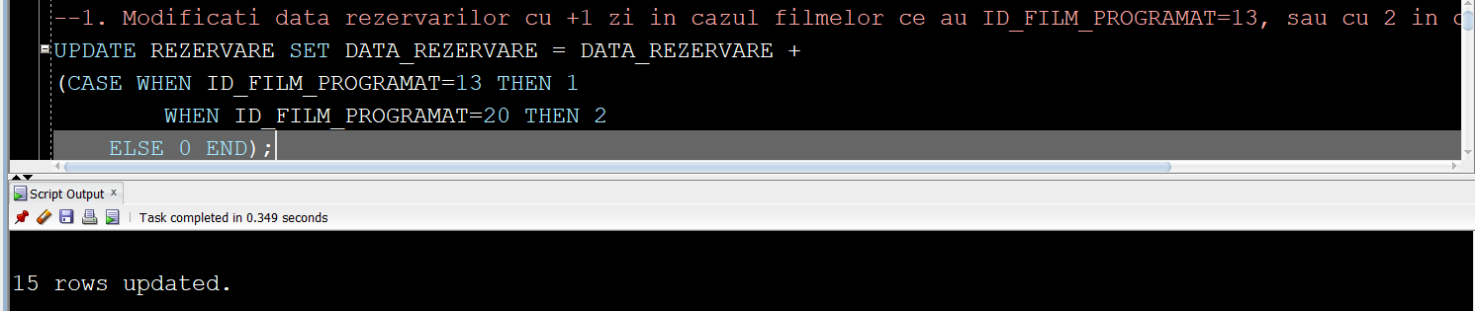

***--2. Modificati capacitatea salii ce are ca id=1, cu pretul filmului programat in acea sala***

UPDATE SALA S SET CAPACITATE = (SELECT PRET FROM FILM_PROGRAMAT F WHERE S.ID_SALA = F.ID_SALA)

WHERE ID_SALA=1;

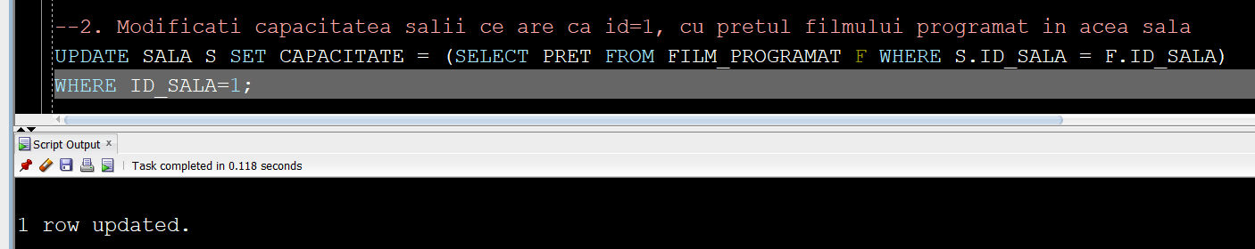

***--3. Sa se mareasca pretul filmului programat cu 15% daca data publicarii este<2000***

UPDATE FILM_PROGRAMAT FP SET PRET = PRET + PRET*

(CASE WHEN (SELECT ANUL_PUBLICARII FROM FILM F WHERE F.ID_FILM = FP.ID_FILM)<2000 THEN 0.15

ELSE 1 END);

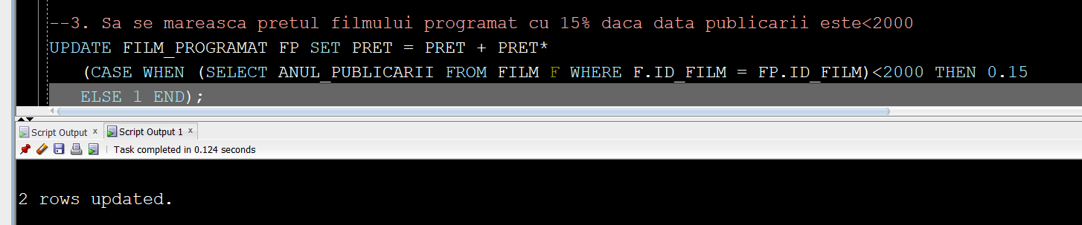

***--4. Sa se modifice numarul locului pentru clientii care au facut rezervare pe 24 Noiembrie cu 24***

UPDATE LOC L SET NUMAR = NUMAR - 1*

(CASE WHEN (SELECT EXTRACT(DAY FROM DATA_REZERVARE) FROM REZERVARE R WHERE L.ID_LOC = R.ID_LOC)=24

AND upper((SELECT EXTRACT(MONTH FROM DATA_REZERVARE) FROM REZERVARE R WHERE L.ID_LOC=R.ID_LOC))=11 then 24

ELSE 0 END);

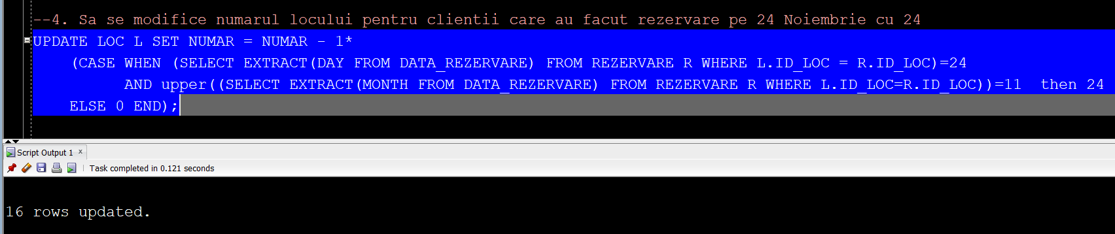

***--5. Sa se reduca capacitatea salii la numarul de rezervari facute***

UPDATE SALA S SET CAPACITATE =

(SELECT COUNT(R.ID_REZERVARE)

FROM REZERVARE R, FILM_PROGRAMAT FP

WHERE R.ID_FILM_PROGRAMAT=FP.ID_FILM_PROGRAMAT AND FP.ID_SALA=S.ID_SALA);

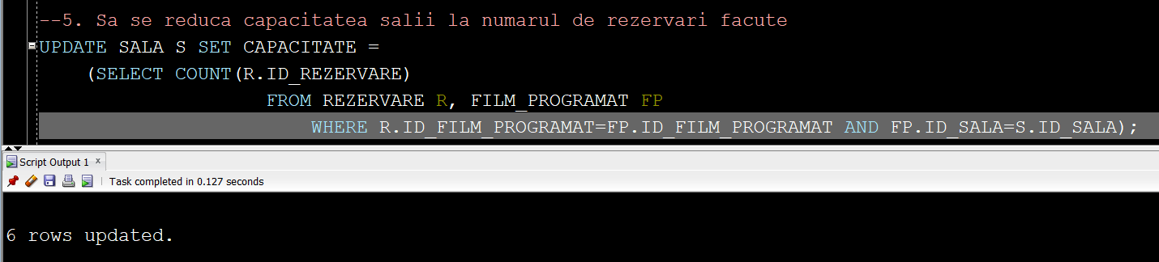

***---6. CRESTETI CAPACITATEA SALII CU ID-UL 1 LA 50 DE PERSOANE SI CU 80 PENTRU ID-UL 2***

UPDATE SALA SET CAPACITATE=

(CASE WHEN ID_SALA=1 THEN 50

WHEN ID_SALA=2 THEN 80 END);

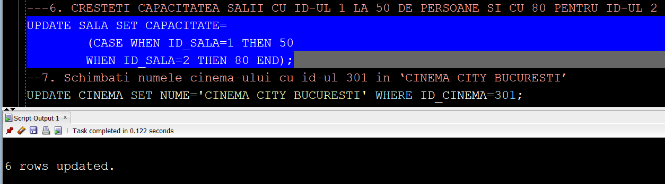

***--7. Schimbati numele cinema-ului cu id-ul 301 in ‘CINEMA CITY BUCURESTI’***

UPDATE CINEMA SET NUME='CINEMA CITY BUCURESTI' WHERE ID_CINEMA=301;

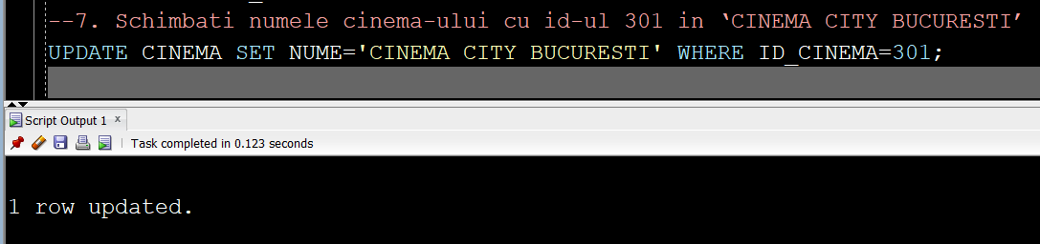

**Exemple de interogari ale inregistrarilor:**

1. **Utilizand jonctiuni**

***--1. Sa se afiseze toate rezervarile clientilor ale caror numere de telefon au prefixul '0765'***

SELECT R.ID_REZERVARE, c.NUMAR_TELEFON

FROM REZERVARE R, CLIENT C

WHERE R.ID_CLIENT=C.ID_CLIENT AND C.NUMAR_TELEFON LIKE '0765%';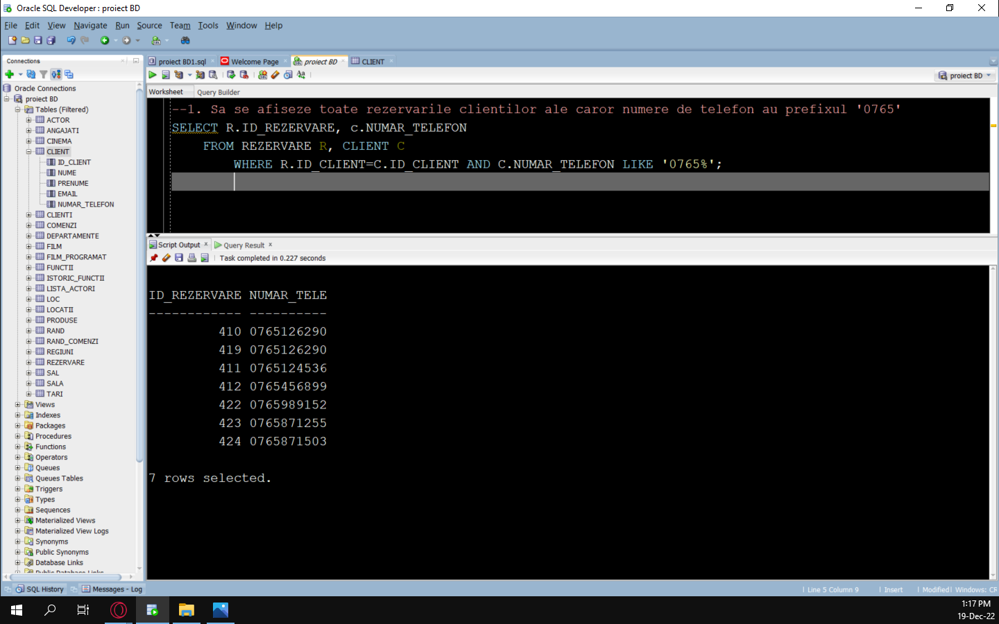

***---2. Sa se afiseze numele filmelor ce sunt progromate in sali ce au capacitate de peste 30 de personae***

SELECT F.NUME, S.CAPACITATE "CAPACITATE SALA"

FROM FILM F, FILM_PROGRAMAT FP, SALA S

WHERE F.ID_FILM=FP.ID_FILM AND FP.ID_SALA=S.ID_SALA AND S.CAPACITATE>30;

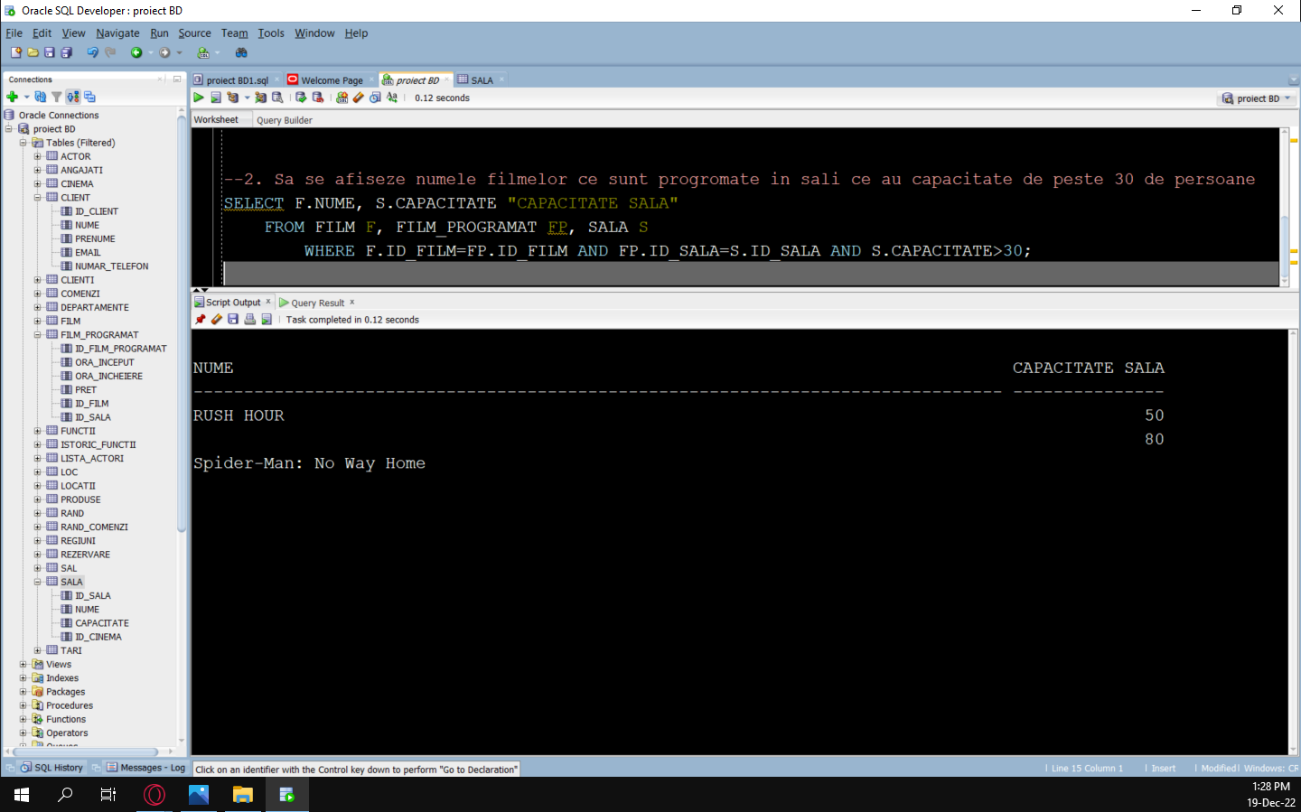

***--3. Sa se afiseze randurile in care vor sta persoane care au facut rezervare dupa data de 25-NOV-2022***

SELECT R.ID_RAND, RE.DATA_REZERVARE

FROM RAND R, LOC L, REZERVARE RE

WHERE R.ID_RAND=L.ID_RAND AND L.ID_LOC=RE.ID_LOC AND

RE.DATA_REZERVARE>to_date('25-11-2022','dd-mm-yyyy');

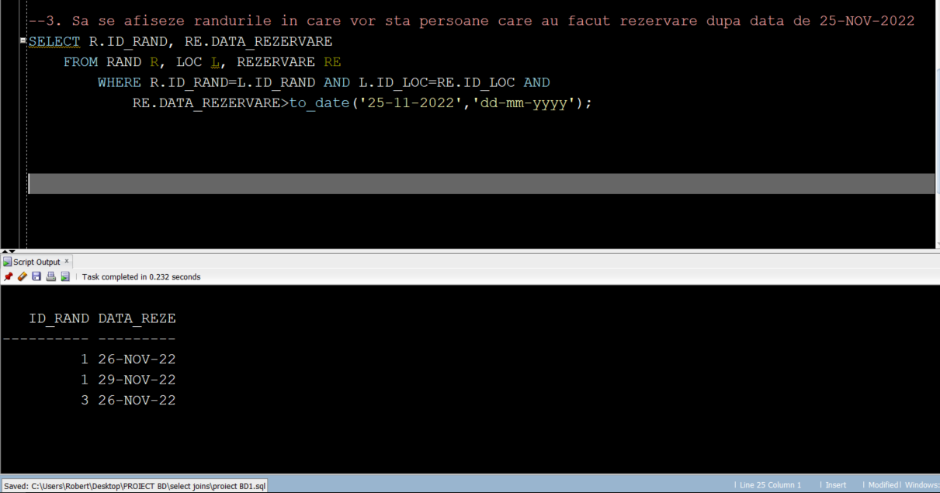

***--4. Sa se afiseze clientii care au facut rezervare la filme mai ieftine de 20 de lei***

SELECT C.NUME || ‘ ‘ || C.PRENUME AS "Client"

FROM CLIENT C, REZERVARE R, FILM_PROGRAMAT FP

WHERE C.ID_CLIENT=R.ID_CLIENT AND R.ID_FILM_PROGRAMAT=FP.ID_FILM_PROGRAMAT

AND FP.PRET<20;

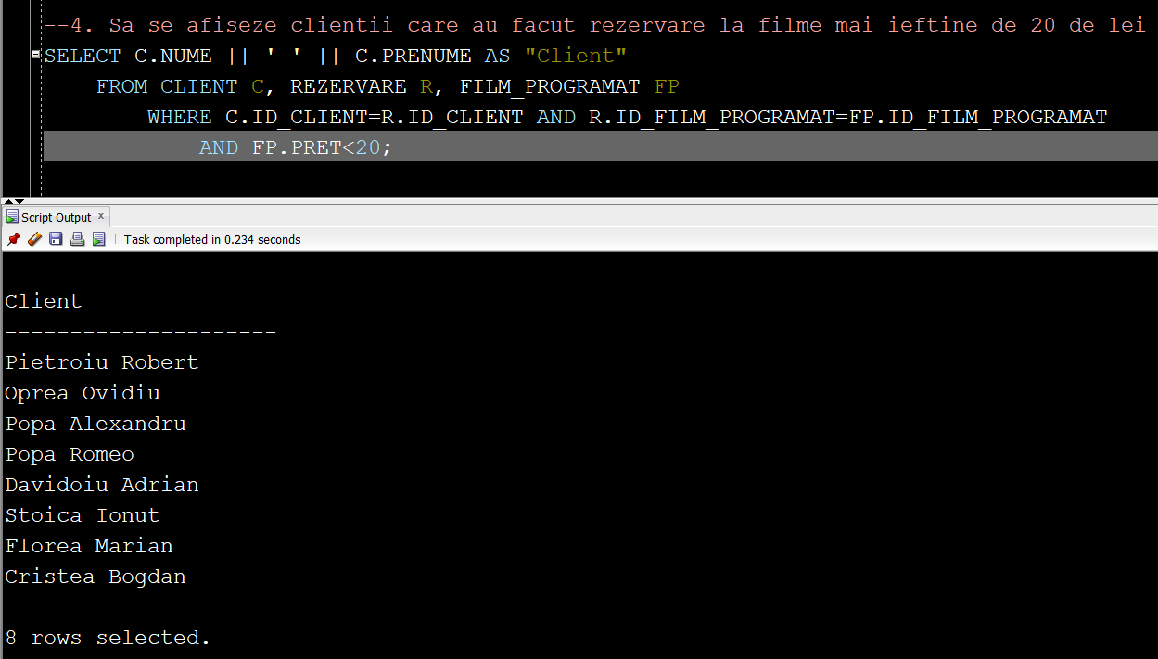

***--5. Sa se afiseze actorii care joaca in filme programate in cinema-ul cu ID=600;***

SELECT A.ID_ACTOR || ' ' || A.NUME AS "ACTOR"

FROM ACTOR A, LISTA_ACTORI LA, FILM F, FILM_PROGRAMAT FP, SALA S, CINEMA C

WHERE A.ID_LISTA=LA.ID_LISTA AND LA.ID_FILM=F.ID_FILM AND F.ID_FILM=FP.ID_FILM AND

FP.ID_SALA=S.ID_SALA AND S.ID_CINEMA=C.ID_CINEMA AND C.ID_CINEMA=600;

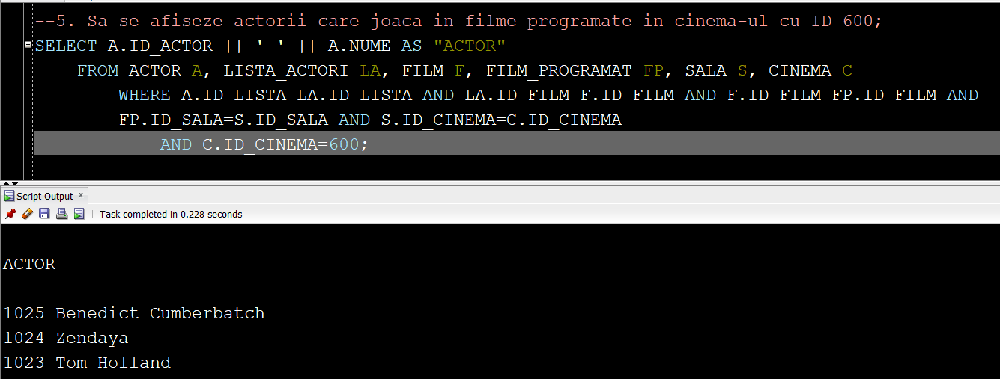

1. **Utilizand functii de grup**

***--1. Sa se afiseze numele filmelor, si numarul de actori care joaca in acestea***

SELECT F.NUME, COUNT(A.ID_ACTOR) "numar actori"

FROM FILM F, LISTA_ACTORI LA, ACTOR A

WHERE F.ID_FILM=LA.ID_FILM AND A.ID_LISTA=LA.ID_LISTA

group by F.NUME, F.TIP;

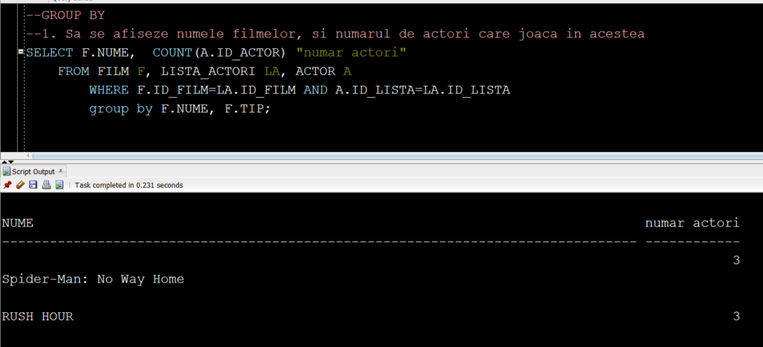

***--2. Sa se afiseze numele cinema-urilor si sala cu capacitatea maxima***

SELECT C.ID_CINEMA, MAX(S.CAPACITATE)

FROM CINEMA C, SALA S

WHERE C.ID_CINEMA=S.ID_CINEMA

group by C.ID_CINEMA;

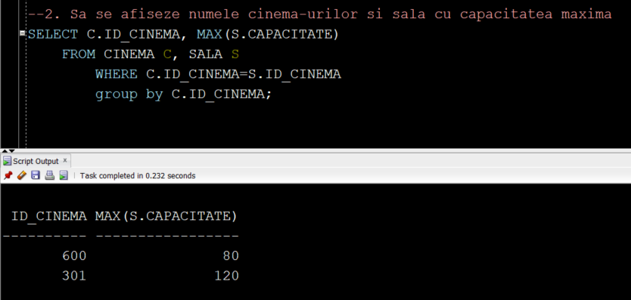

***--3. Sa se afiseze filmele cu cei mai tineri actori, alaturi de varsta minima a unui actor***

SELECT distinct F.nume "NUME FILM", a.varsta

FROM FILM F, ACTOR A, LISTA_ACTORI LA

WHERE F.ID_FILM=LA.ID_FILM AND A.ID_LISTA=LA.ID_LISTA

group by F.nume, a.nume, a.varsta

having a.varsta<=all(select varsta from actor);

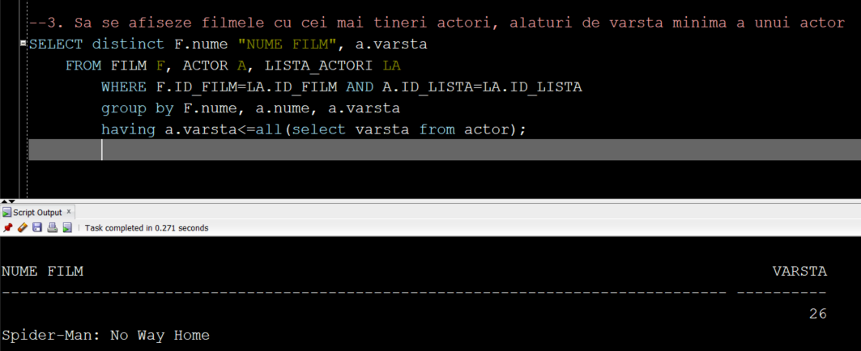

***--4. Sa se afiseze zilele in care s-au facut cele mai multe rezervari,***

***-- in ordinea descrescatoare a numarului acestora***

SELECT R1.DATA_REZERVARE, COUNT(R2.ID_REZERVARE)

FROM REZERVARE R1 , REZERVARE R2

WHERE R1.ID_REZERVARE=R2.ID_REZERVARE group by R1.DATA_REZERVARE

ORDER BY COUNT(R2.ID_REZERVARE) DESC;

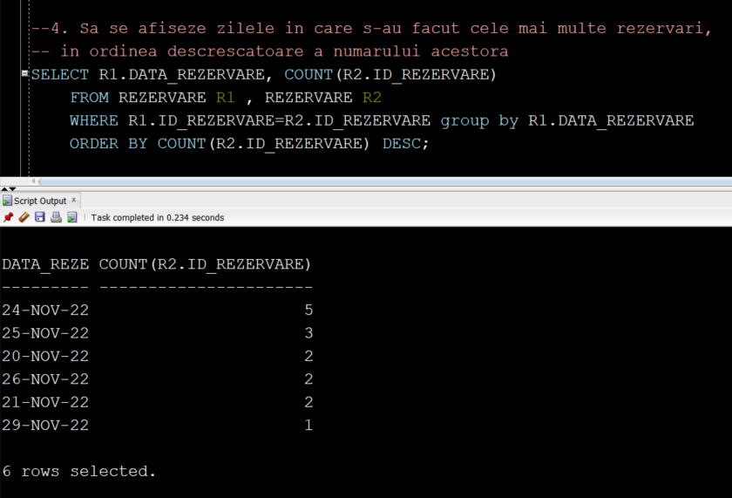

***--5. Sa se afiseze filmul vizionat de cei mai multi clienti***

SELECT MAX(F.NUME) "FILM", COUNT(DISTINCT R1.ID_REZERVARE) "Numar rezervari"

FROM FILM F, FILM_PROGRAMAT FP, REZERVARE R1, REZERVARE R2

WHERE F.ID_FILM=FP.ID_FILM AND FP.ID_FILM_PROGRAMAT=R1.ID_FILM_PROGRAMAT

group by F.NUME

order by COUNT(DISTINCT R1.ID_REZERVARE) desc

fetch next 1 row only;

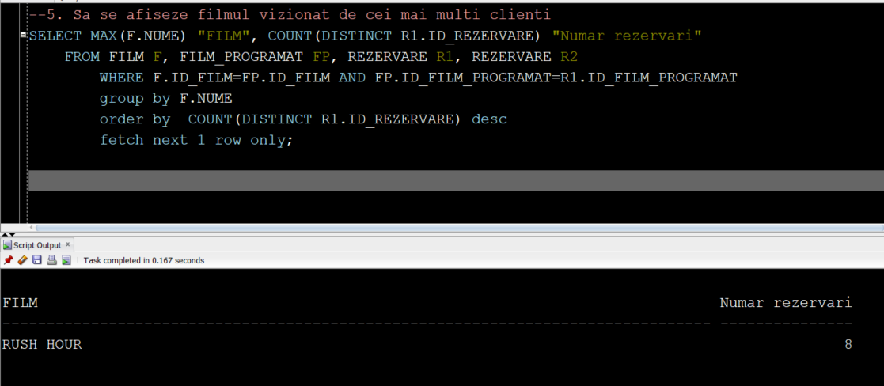

1. **Utilizand subcereri**

***--1. Sa se afiseze randurile in care vor sta cel putin 2 persoane care au facut rezervarea in aceeasi zi***

SELECT distinct R.ID_RAND

FROM RAND R, LOC L, REZERVARE RE , CLIENT C

WHERE R.ID_RAND=L.ID_RAND AND L.ID_LOC=RE.ID_LOC AND

RE.DATA_REZERVARE IN (SELECT DATA_REZERVARE FROM REZERVARE);

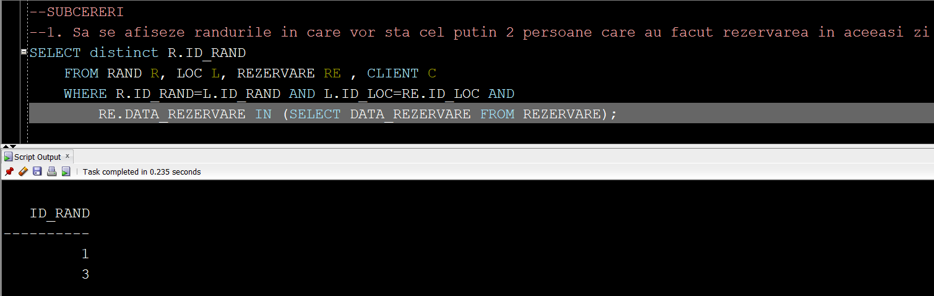

***--2. Sa se afiseze actorii care au jucat in cel putin un film***

SELECT A.ID_ACTOR || ' ' || A.NUME AS "ACTOR", ID_LISTA

FROM ACTOR A

WHERE A.ID_LISTA IN (SELECT ID_LISTA FROM LISTA_ACTORI);

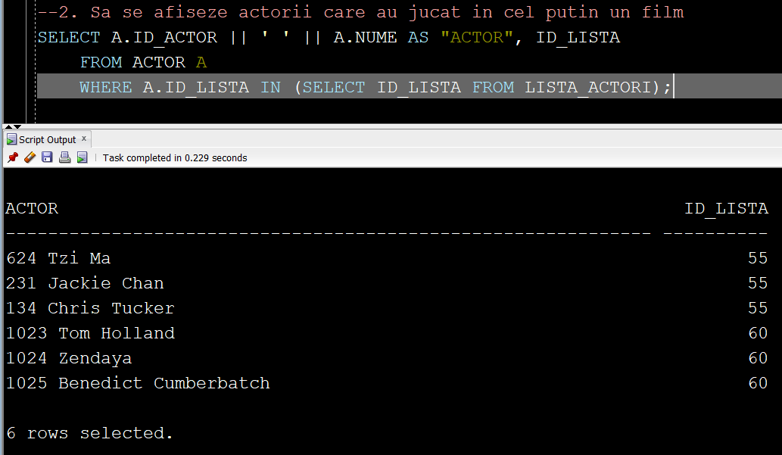

***--3. Sa se afiseze filmele programate in sala cu cele mai multe locuri***

SELECT FP.ID_FILM_PROGRAMAT

FROM FILM_PROGRAMAT FP, SALA S

WHERE FP.ID_SALA=S.ID_SALA AND S.CAPACITATE>ANY(SELECT CAPACITATE FROM SALA);

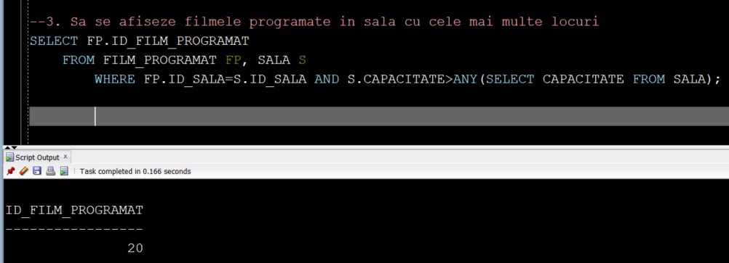

***--4. Sa se afiseze actorii care participa la cel mai recent film aparut***

SELECT NUME "ACTOR"

FROM ACTOR WHERE ID_LISTA=(SELECT ID_LISTA FROM LISTA_ACTORI

WHERE ID_FILM=(SELECT ID_FILM FROM FILM

WHERE ANUL_PUBLICARII>ANY(SELECT ANUL_PUBLICARII FROM FILM)));

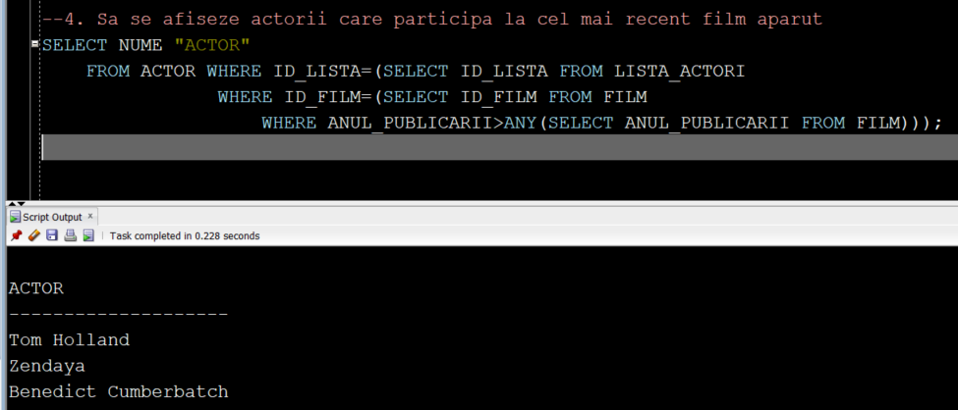

***--5. Sa se afiseze numele, varsta curenta si varsta actorilor in momentul publicarii filmului***

***-- in care au jucat (adica varsta-2022+anul_publicarii)***

SELECT A.NUME, A.VARSTA "VARSTA CURENTA" ,A.VARSTA-2022+(SELECT ANUL_PUBLICARII FROM FILM

WHERE ID_FILM IN (SELECT ID_FILM FROM LISTA_ACTORI WHERE A.ID_LISTA=ID_LISTA)) AS "VARSTA"

FROM ACTOR A;

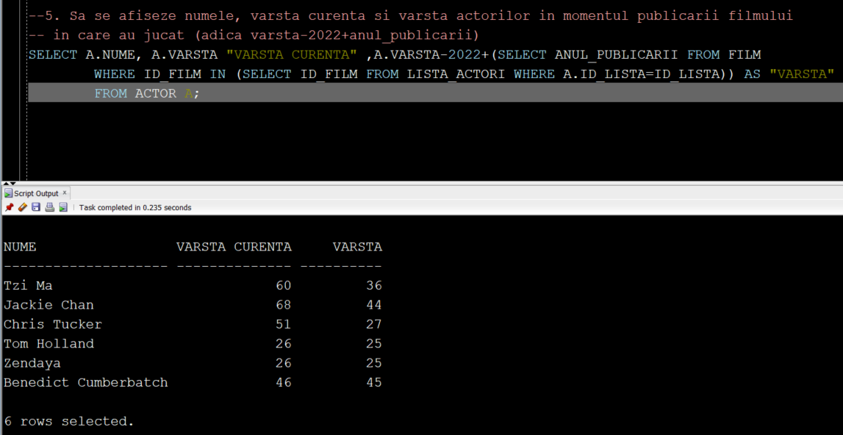

**Utilizarea tabelelor virtuale**

***--1. Creati o tabela virtuala care afiseaza numele clientilor care au facut rezervare pe data de 25-NOV-2022***

CREATE OR REPLACE VIEW view1 AS

SELECT C.NUME "Client"

FROM CLIENT C, REZERVARE R

WHERE C.ID_CLIENT=R.ID_CLIENT AND DATA_REZERVARE=TO_DATE('25-11-2022', 'dd-mm-yyyy');

SELECT * FROM view1;

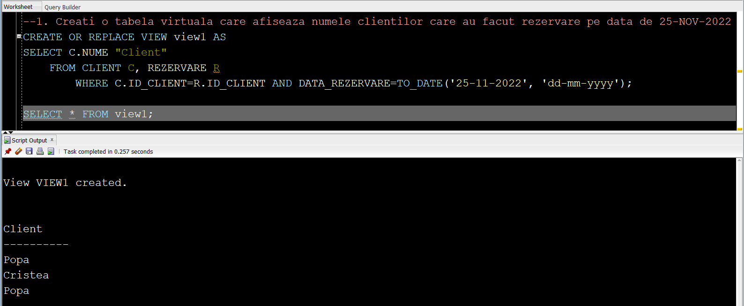

***--2. Creati o tabela virtuala care afiseaza toate id_urile rezervarilor la filme de tip 'ACTIUNE'***

CREATE OR REPLACE VIEW view2 AS

SELECT R.ID_REZERVARE

FROM REZERVARE R, FILM_PROGRAMAT FP, FILM F

WHERE R.ID_FILM_PROGRAMAT=FP.ID_FILM_PROGRAMAT AND FP.ID_FILM=F.ID_FILM

AND F.TIP='ACTIUNE';

SELECT * FROM view2;

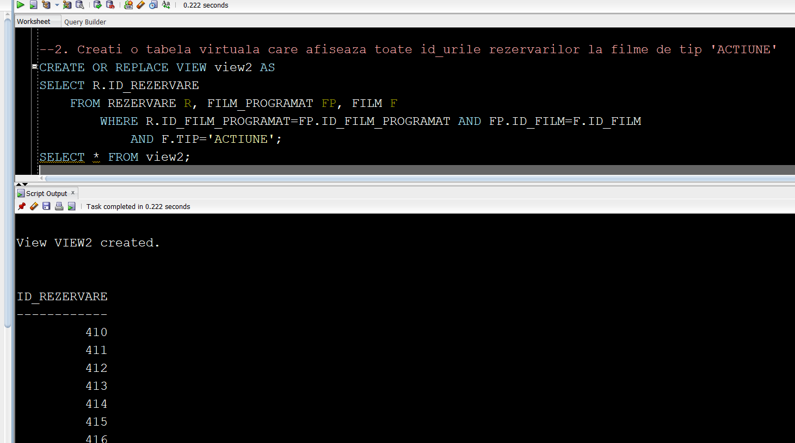

***--3. Creati o tabela virtuala in care sa se afiseze locurile care au ID-ul egal cu numarul***

CREATE OR CREATE OR REPLACE VIEW view3 AS

SELECT L.ID_LOC "ID LOC", NUMAR "NUMAR LOC"

FROM LOC L

WHERE L.ID_LOC IN (SELECT NUMAR FROM LOC WHERE L.ID_LOC=ID_LOC);

SELECT * FROM view3;

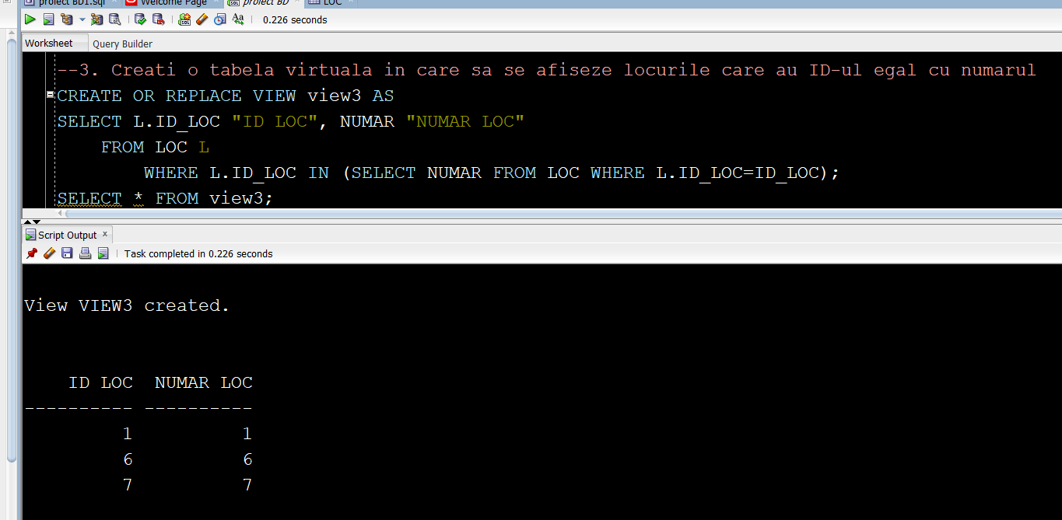

***--4. Creati o tabela virtuala care afiseaza toate cinema-urile in Bucuresti***

CREATE OR REPLACE VIEW view4 AS

SELECT ID_CINEMA, NUME "NUME CINEMA", ADRESA

FROM CINEMA

WHERE UPPER(CINEMA.NUME) LIKE '%BUCURESTI%';

SELECT * FROM view4;

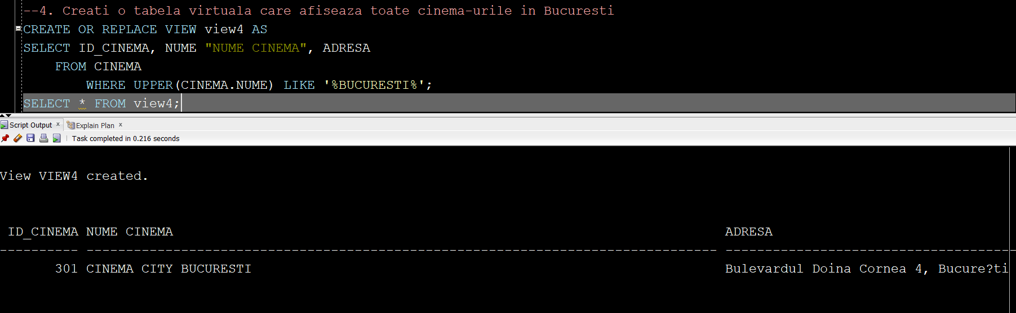

***--5. Creati o table virtuala in care sa se afiseze actorii care joaca in cel mai lung film, alaturi de lungimea acestuia***

CREATE OR REPLACE VIEW view5 AS

SELECT A.ID_ACTOR, A.NUME, F.DURATA_MINUTE

FROM ACTOR A, LISTA_ACTORI LA, FILM F

WHERE A.ID_LISTA=LA.ID_LISTA AND LA.ID_FILM=F.ID_FILM AND F.DURATA_MINUTE>ANY(SELECT DURATA_MINUTE FROM FILM);

SELECT * FROM view5;

